


FACE RECOGNITION ATTENDANCE SYSTEM

A PROJECT REPORT
(Phase-I)

Submitted by

SRINIDHI S (1518106087)

in partial fulfillment for the award of the degree

of

BACHELOR OF TECHNOLOGY

IN

INFORMATION TECHNOLOGY

SONA COLLEGE OF TECHNOLOGY, SALEM-5
(Autonomous)

MAY 2021

ANNA UNIVERSITY : CHENNAI 600 025

BONAFIDE CERTIFICATE

Certified that this project report “FACE RECOGNITION ATTENDANCE SYSTEM” is the bonafide work of “ALBEENA A (1518106009), ANNAPOORANI G (1518106011), SRINIDHI S (1518106087) ” who carried out the project work under my supervision.

SIGNATURE SIGNATURE
Dr.J.Akilandeswari | Dr.J.Senthilkumar
HEAD OF THE DEPARTMENT | SUPERVISOR
Professor | Professor
Department of Information Technology | Department of Information Technology
Sona College of Technology, | Sona College of Technology,
Salem-636 005. | Salem-636 005.

Submitted for mini Project viva voce examination held on .....................................

INTERNAL EXAMINER | EXTERNAL EXAMINER

ABSTRACT
Smart Attendance using Real-Time Face Recognition is a real-world solution which comes with day to day activities of handling student attendance system. Face recognition-based attendance system is a process of recognizing the students face for taking attendance by using face biometrics based on high - definition monitor video and other information technology. In my face recognition project, a computer system will be able to find and recognize human faces using the webcam. Numerous algorithms and techniques have been developed for improving the performance of face recognition but the concept to be implemented here is Deep Learning. It helps in conversion of the frames of the video into images so that the face of the person can be easily recognized for their attendance so that the attendance database can be easily reflected automatically.

ACKNOWLEDGEMENT

First and foremost, we thank to power of almighty for showing us inner peace and for all blessings. Special gratitude to our parents, for showing their support and love always.

We express our sincere thanks to Chairman Sri.C.Valliappa and Principal Dr. SRR SENTHILKUMAR for providing adequate facilities to complete the project.

We are immensely grateful to Head of Information Technology, Dr.J.Akilandeswari for the continues encouragement to complete the project.

We express our heartfelt thanks to our project supervisor MS.R.Sangeethapriya for her valuable guidance and fruitful discussions throughout the course of the project work.

We feel proud in sharing this success with all our staff members and friends who helped directly or indirectly in completing this project successfully.

TABLE OF CONTENTS

CHAPTER NO | TITLE | PAGE NO
 | ABSTRACT
 | LIST OF FIGURES | V
 | LIST OF SYMBOLS AND ABBREVIATION | VII
1. | INTRODUCTION
 | - About the Project
 | - Deep Learning
 | - CNN Algorithm
 | - Python
2. | LITERATURE SURVEY
 | 2.1 Literature Survey
3. | HARDWARE AND SOFTWARE REQUIREMENTS
 | 3.1 Hardware Requirements
 | 3.2 Software Requirements
4. | PROJECT DESCRIPTION
 | 4.1 Scope of the Project
 | 4.2 System Architecture and Design
 | 4.2.1 Dataset Creation
 | 4.2.2 Face Recognition
 | 4.2.3 Attendance Marking
5. | RESULTS
 | 5.1 Sample Output
6. | CONCLUSION AND FUTURE ENHANCEMENTS
 | 6.1 Conclusion
 | 6.2 Future Enhancements
7. | APPENDICES
8. | REFERENCES

LIST OF FIGURES

FIGURE NO. TITLE PG NO.
2.1 Simplified block diagram of the encryption scheme 6
2.2 Detailed block diagram of the encryption part 8
4.1 Level 1 DFD 13
4.2 Level 2 DFD 14
5.1 Login page 16
5.2 Testing and generation of new GUID 17
5.3 Viewing the users of the interface 18
5.4 Performing Encryption 19
5.5 Performing Decryption 20
5.6 After performing Encryption and Decryption 21
5.7 Home page 22
5.8 Image Encryption and Decryption 23
5.9 File Encryption and Decryption 24

LIST OF ABBREVIATIONS
ABBREVIATIONS
GUID - Global Unique IDentifier.
MD5 - Message Digest (5-Version)
CAST 128 - Algorithm, also called as Cast 5

CHAPTER-1
INTRODUCTION

1.1 ABOUT THE PROJECT
Face recognition is a method to identify or verify the identity of an individual using their face. Face recognition has been used for various applications such as automatic classroom attendance management system, surveillance of access restricted zones including living spaces for intruder detection, recognition of celebrities in public space, recognition of house inmates by networked home automation system and many more. Most of the face recognition systems designed consist of two major modules: feature extraction and classifier. The conventional methods like Eigenfaces and Fisher faces are sensitive to lighting, noise, posture, obstruction, illumination etc, whereas Convolutional Neural Network (CNN) is a deep learning algorithm, most commonly used in applications using images, because it performs the combined task of feature extraction and classification. Hence in this project, we first capture an image of person and utilize the OpenCV module to detect and frame the faces in that image. In the next stage we enhance these frames using an image enhancing model. In the final stage, we build a Convolution Neural Network (CNN) to train these facial images and using the camera we can detect the person and make attendance in the exel sheet.

1.2 DEEP LEARNING
Deep learning has a varied range of applications, which has led to a rise in its popularity and its usage in various industries. It is used by several organizations from different sectors or industries. Deep learning algorithms seek to explore and analyze the unknown structure in the input distribution to discover useful representations with the help of feature learning, continually evolving and improvising with the input of additional data.The scope of deep knowledge for its self-adaptive feature is boundless in today’s time. The deep learning discipline isn’t simple, and its complete capabilities have not yet been explored. But it is a potent branch of machine learning and has a lot of scopes soon.

1.3 CNN ALGORITHM
The feature maps of a CNN capture the result of applying the filters to an input image. i.e at each layer, the feature map is the output of that layer. The reason for visualising a feature map for a specific input image is to try to gain some understanding of what features our CNN detects
A Convolutional Neural Network is a Deep Learning algorithm which can take in an input image, assign importance to various aspects/objects in the image and be able to differentiate one from the other. The pre-processing required in a Convolution Neural Network is much lower as compared to other classification algorithms. While in primitive methods filters are hand-engineered, with enough training, Convolution Neural Network have the ability to learn these filters/characteristics.
The architecture of a Convolution Neural Network is analogous to that of the connectivity pattern of Neurons in the Human Brain and was inspired by the organization of the Visual Cortex. Individual neurons respond to stimuli only in a restricted region of the visual field known as the Receptive Field. A collection of such fields overlap to cover the entire visual area.
- To recognise an image with highest level of accuracy we need to use deep learning algorithms like convolutional neural networks.
- CNNs can be thought of automatic feature extractors from the image. While using an algorithm with pixel vector we lose a lot of spatial interaction between pixels, a CNN effectively uses adjacent pixel information to effectively down sample the image first by convolution and then uses a prediction layer at the end.
- Due to these features of CNN we get highest accuracy level for our model and has achieved an efficient intelligent album creator.
  - PYTHON
Python is a dynamic language and reduces complexity when it comes to collaborating meaning you can implement functionality with less code. Unlike C++, where all significant compilers tend to do specific optimization and can be platform specific, Python code can be run on pretty much any platform without wasting time on specific configurations
The working of the system we proposed involves three steps:
1.Creating a dataset.
2.Training the model.
3.Recognizing the face.
4.Marking the attendance.
The libraries we used,
1.Opencv: to process the image/video.
2.Numpy: to work with pixels in form of arrays.
3.Os: to change/create directory and also to open files in the directory.
4.keras: high-level interface and uses Tensorflow for its backend
5.Tensorflow: to create layers and create/load models.
6.Xlwt: to create/read/write to excel sheet.
7.CV2: to search for faces within a the screen or image

CHAPTER-2
LITERATURE SURVEY

2.1 LITERATURE SURVEY

Wael AbdAlmageed et al. [10] introduce this method and system for face recognition using multiple pose-aware deep learning models. In this representation, a face image is processed by several pose-specific deep convolutional neural network (CNN) models to generate multiple pose-specific features. 3D rendering is used to generate multiple face poses from the input image. Sensitivity of the recognition system to pose variations is reduced since authors use an ensemble of
pose-specific CNN features. Authors present extensive experimental results on the effect of landmark detection, CNN layer selection and poses model selection on the performance of the recognition pipeline. This novel representation achieves better results than the state-of-the-art on IARPA’s CS2 and NIST’s IJB-A in both verification and identification (i.e. search) tasks.
Changxing Ding et al. [11] proposes a novel face identification framework capable of handling the full range of pose variations within ±90° of yaw. The proposed
framework first transforms the original pose-invariant face recognition problem into a partial frontal face recognition problem. A robust patch-based face representation scheme is then developed to represent the synthesized partial frontal faces. For each patch, a transformation dictionary is learnt
under the proposed multi-task learning scheme. The transformation dictionary transforms the features of different poses into a discriminative subspace. Finally, face matching
is performed at patch level rather than at the holistic level. Extensive and systematic experimentation on FERET, CMUPIE, and Multi-PIE databases shows that the proposed method consistently outperforms single-task-based baselines as well as state-of-the-art methods for the pose problem.
Authors further extend the proposed algorithm for the unconstrained face verification problem and achieve toplevel performance on the challenging LFW data set.
Deep learning provides a natural way to obtain feature representations from data without relying on hand-crafted descriptors. In this paper, Xue-wen Chen et al. [12] propose to learn deep feature representations using unsupervised and supervised learning in a cascaded fashion to produce
generically descriptive yet class specific features. The proposed method can take full advantage of the availability of large-scale unlabeled data and learn discriminative features (supervised) from generic features (unsupervised). It is then applied to multiple essential facial regions to obtain
multi-channel deep facial representations for face recognition. The efficacy of the proposed feature
representations is validated on both controlled (i.e., extended Yale-B, Yale, and AR) and
uncontrolled benchmark face databases. Experimental results show its effectiveness.
The system uses an eye scan sensor and Daugman’s algorithm for the iris recognition. Patil et al. in [7] applied face recognition for classroom attendance. They used Eigenface for the recognition, but the overall accuracy of the system was not mentioned in the paper.
Tharanga et al. in [9] used Principle Component Analysis (PCA) method for the face recognition for their attendance system, achieving the accuracy of 68%. Due to the rapid progress in deep learning, the accuracy of face recognition is drastically improved by the usage of deep CNNs.
Schroff et al. in [10] presented the revolutionary system – FaceNet which depends on the Deep Neural Network (DNN) for the face recognition task. The proposed method achieved astonishing results on the Labeled Faces in the Wild (LFW) dataset, 99.63% accuracy.

CHAPTER-3
HARDWARE AND SOFTWARE REQUIREMENTS

3.1 HARDWARE REQUIREMENT
Operating system : | Windows 10
Hard disk : | 1 TB
RAM : | 4 GB
3.2 SOFTWARE REQUIREMENT
Operating System : | Windows 10
Tool Used : | Jupyter Notebook, Microsoft Exel
Front end : | Python
Back end : | Python,Keras,Tenserflow

CHAPTER-4
PROJECT DESCRIPTION

4.1 SCOPE OF THE PROJECT
Facial Recognition modules tend to work in different forms, but the one concept that holds true for any module is the comparison of facial features that are selected uniquely. It can be called as an application that works with artificial intelligence that identifies people based on their unique features like shape, color, or any other unique feature. This is also implementable in various platforms. This technology is widely used in mobile phones in this era by tech giants as it is extremely efficient and hardly any work is to be done by the user. Security of this system must be made better as it does have flaws of its own. With better modules being built everyday it promises to be the most efficient way of security accessing.

4.2 SYSTEM ARCHITECTURE AND DESIGN

Dataset creation using cv2

Spliting as train and test folders

Image preprocessing

Building CNN model

Predicition of the person using webcam

Marking the attendance

4.2.1 Dataset Creation:
The function saves the image as a cv2 object.It then greys out the complete image. This is done so that CV2 can process through the image faster with better results.A cascade classifier is defined with built in cascade xml files.The cascade classifies calls a multi selection detect method which detects patterns with given arguments.Few of the arguments given are scaling factor, minimum number of neighbours and the minimum size of the pattern to be detected (30 * 30 usually for a face). The multiselect ion detect method returns an object which has all the 4 points of all rectangles of all the faces detected.We Loop through the object and colour the rectangles for reference and at the same time, each rectangle is again converted back to a coloured image and saved in another folder. This folder consists of all the faces openCv hasdetected. The first step of the project is completed by extracting the faces from the input image for attendance.

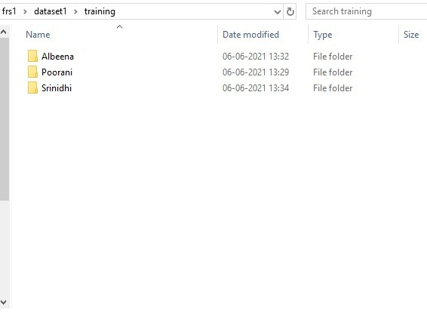

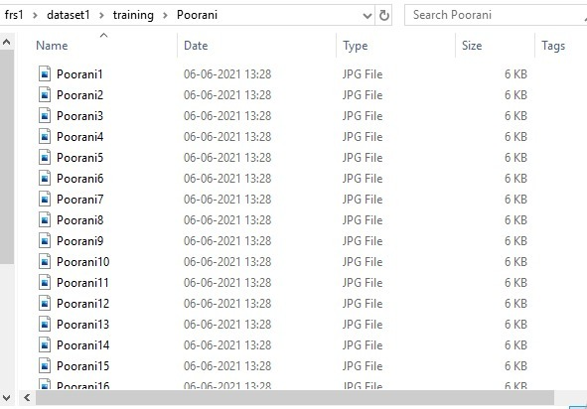

4.2.2 Face Recognition Model
Face recognition is a method to identify or verify the identity of an individual using their face. Face recognition has been used for various applications such as automatic classroom attendance management system, surveillance of access restricted zones including living spaces for intruder detection, recognition of celebrities in public space, recognition of house inmates by networked home automation system and many more. Most of the face recognition systems designed consist of two major modules: feature extraction and classifier. The conventional methods like Eigenfaces and Fisher faces are sensitive to lighting, noise, posture, obstruction, illumination etc, whereas Convolutional Neural Network (CNN) is a deep learning algorithm, most commonly used in applications using images, because it performs the combined task of feature extraction and classification. Hence in this project, we first capture an image of person and utilize the OpenCV module to detect and frame the faces in that image. In the next stage we enhance these frames using an image enhancing model. In the final stage, we build a Convolution Neural Network (CNN) to train these facial images and using the camera we can detect the person and make attendance in the exel sheet.
Train the model with Neural Networks. We use the Tensorflow Keras Library in python as they contain almost all the algorithms and required functions to build the model. We again use the ImageDataGenerator to preprocess the image. This is a very basic preprocessing used to store all the images into 2 variables as 2 different batches. We then loop through the batches and separate the training and the test dataset into a python list. These lists are further converted into numpy arrays for the Neural Network model which we build later. After the preprocessing of the images is done and finally converted into a numpy array, they are ready to be trained.We then create a sequential model from keras which is basically used to create a layered neural network. We add multiple layers to this model for it to work.The first layer is the Convolution layer with 32 neurons for the input image to connect to. We use the activation function of relu in this.The second layer is the pooling layer with a pool size of 2*2. We use the MaxPooling2d module while others also can be used.Once the layer is pooled, they are flattened out to a single array, which is basically converted into those many neurons of 1 dimension.These final layers are used for classification of the image.We add a dense layer of 500 neurons with an activation function of relu. We finally add the output dense layer with several neurons equal to the number of faces or the number of classes.This model is finally optimized with adam optimizer to find the minimum gradient descent.Once the model is trained, we store the fitted model

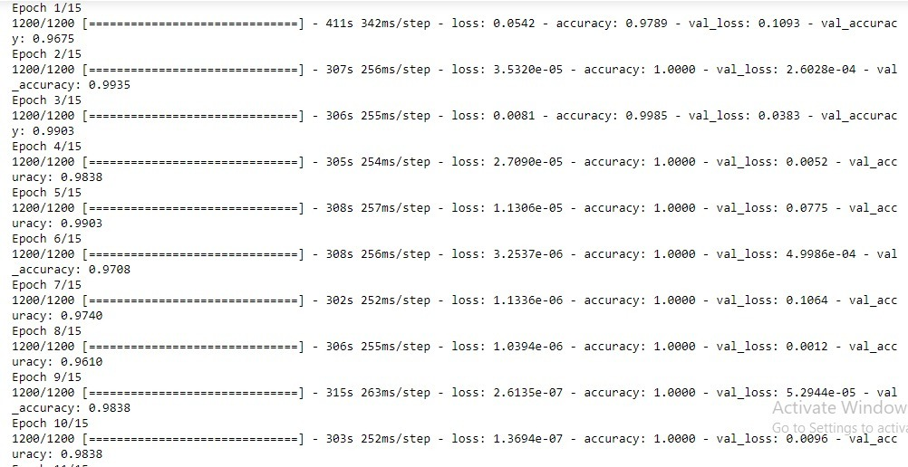

4.2.3 Attendance Marking
An end-to-end face identification and attendance approach using Convolutional Neural Networks (CNN), which processes the video of the class and mark the attendance of the entire class simultaneously. One of the main advantages of the proposed solution is its robustness against usual challenges like occlusion (partially visible/covered faces), orientation, alignment and luminescence of the classroom. An automated attendance system is used for marking human face recognition in real time for college to mark the attendance for their staff and students. Smart automated attendance marking using real time face recognition is a real world solution which comes with day to day activities of handling employees. Here multiple user faces are detected and recognized with the data base trained multiple texture based notability.

CHAPTER-6
CONCLUSION AND FUTURE ENHANCEMENTS

6.1 CONCLUSION
Thus In this way, we proposed a system which works on concept of machine learning, Image processing and Android app creation, which keeps a track of an educational institutional students attendance record at run-time and gives a report to all the individuals, part of these system. It also provides various features, according to the individual present,such as for teacher, message sending rights, for admin removing or adding an individual and so on. As image processing and ML
combined is a research field, our system can be extended to performing better, this can be its future
scope. Also, it can be improved by getting a more clear image and processing a high resolution in less time. Thus increasing the efficiency of time and space complexity, by building a better or revising the current Feature extractionand classification algorithms.

6.2 FUTURE ENHANCEMENTS
Almost all academic institutions require attendance record of students and maintaining attendance manually can be hectic as well as time consuming task. Hence maintaining attendance automatically with the help of face recognition will be very helpful and less prone to errors as compared to manual process. This will also reduce manipulation of attendance record done by students and it will save time as well. The future scope of the proposed work can be, capturing multiple detailed images of the students and using any cloud technology to store these images. The system can be configured and used in Atm machines to detect frauds.Also, the system can be used at the time of elections where the voter can be identified by recognizing the face.

CHAPTER-8
REFERENCES

[1] M.K. Yeop Sabri, M.Z.A. Abdul Aziz, M.S.R. Mohd Shah, M.F Abd Kadir, "Smart Attendance System by suing RFID", Applied Electromagnetics 2007. APACE 2007. Asia -Pacific Conference on, 4–6Dec. 2007.
[2] R. Apoorv, P. Mathur, "Smart attendance management using Bluetooth Low Energy and Android", 2016 IEEE Region 10 Conference (TENCON), 2016.K.
[3] N. I. Zainal, K. A. Sidek, T. S. Gunawan, H. Mansor, M. Kartiwi, "Design and Development of Portable Classroom Attendance System Based on Arduino and Fingerprint Biometric", proc.of The IEEE 5th International Conference on Information and Communication Technology for The Muslim World (ICT4M), pp. 1-4, 17–18 Nov. 2014.
[4] K.Lakshmi Sudha, Shirish Shinde, Titus Thomas, “Barcode based student attendance system” International Journal of Computer Applications (0975 – 8887) Volume 119 – No.2, June 2015.
[5] S. Dey, S. Barman, R. K. Bhukya, R. K. Das, B C Haris, S. R. M. Prasanna, R. Sinha, "Speech biometric based attendance system", National Conference on Communications, 2014.
[6] Muhammet Baykar, Uğur Gürtürk, Ertuğrul Karakaya, “NFC based smart mobile attendance system”, 2017 International Conference on Computer Science and Engineering (UBMK)
[7] Wagh, J Priyanka, Agruti Chaudhari, Roshani Thakare, Shweta Patil,"Attendance system based on face recognition using eigen face and PCA algorithms", Green Computing and Internet of Things (ICGCIoT) 2015 International Conference on, pp. 303-308, 2015.
[8] N. Dalal and B. Triggs. Histograms of oriented gradients for human detection. In CVPR, volume 2, p886-893, 2005
[9] V. Kazemi, J. Sullivan, "One millisecond face alignment with an ensemble of regression trees", Proceedings of the IEEE Conference on ComputerVision and Pattern Recognition, pp. 1867-1874, 2014.
[10] Y. Wen, K. Zhang, Z. Li, and Y. Qiao. A discriminative feature learning approach for deep face recognition. In European Conference on Computer Vision (ECCV), pages 499–515, 2016.
[11] M.U. Rahman, (2012): A comparative study on face recognition
techniques and neural network, presented at IEEE CoRR, 2012.
[12] F. Schroff, D. Kalenichenko, and J. Philbin. Facenet: A unified
embedding for face recognition and clustering. arXiv preprint
arXiv:1503.03832, 2015.
[13] Mehul K Dabhi, Bhavna K Pancholi, “Face Detection System Based on
Viola - Jones Algorithm” International Journal of Science and Research
(IJSR), Volume 5 Issue 4, April 2013.

